4944 Geelong-Bacchus Marsh Rd Maddingley, VIC, 3340

Email: [ecwcaravans@gmail.com](mailto:ecwcaravans@gmail.com)

Phone: 0424 503 022

2010 Majestic Knight Bunk Van

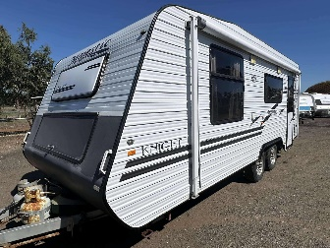

2010 Majestic Knight Bunk caravan with annex, battery setup, aircon and more. This great caravan has: Queen Island bed with storage, large bunks. -Annex -aircon /heating -Battery setup with charger. -Bike rack -Anderson plug and portable solar available ($380) or roof mounted $780 -Spare tyre -dual axle-Reverse camera -large TV on swivel bracket -12v water pump -12v stereo with speakers -Tv aerial -Currently registered and ready to go. -power lead, hose and waste hose -wheel chocks and caravan mirrors -Trailer-a-mate jack -Great kitchen with 3 way fridge/freezer, tank and mains water setup, microwave, stove with grill and range hood Large L shape couch and table. This caravan has been kept in good condition! 2010 model Tare weight 1778 kg ATM 2178 kg 20 ft $26,800 neg! This beautiful caravan won’t last long on the yard! Located at ECW caravan dealership Bacchus marsh Vic. Delivery and Finance available too!

