4944 Geelong-Bacchus Marsh Rd Maddingley, VIC, 3340

Email: [ecwcaravans@gmail.com](mailto:ecwcaravans@gmail.com)

Phone: 0424 503 022

2014 Majestic Sierra

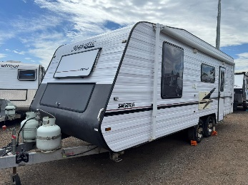

2014 Majestic Sierra with seperate shower and toilet,battery , solar and so much more!! \*Battery with charger \*solar panel with regulator \*washing machine \*Tv on swivel bracket \*Aircon and heating \*12v stereo with speakers \*Large awning \*gas/elec hot water service

\*water tank gauge \*anderson plug to battery \*wind up Tv aerial \*12v pump \*12v lights

\*spare tyre \*2 x water tanks \*extra toilet casset \* full size 3 way fridge and freezer . (Higher so you don’t have to bend ) \*levelling bars \*electric brakes to all wheels \*break away \*tow mirrors

\*power lead , hoses and waste hoses This caravan is a beautiful setup and layout. Setup for free camping, It has a queen Island bed at one end, stunning kitchen in the middle and full size ensuite at back. It has aircon and heating, heaps of storage. Kitchen includes Large 3 way fridge/ freezer, 4 burner stove, range hood , microwave ,mains and tank water. 21 ft

Tare 1962 kg ATM 2300 kg Tow ball 167 kg Comes registered and ready to go. $41,990 neg !

Located at ECW caravan dealership Bacchus marsh vic ! 40-45 min west of melb . Finance and delivery available

