4944 Geelong-Bacchus Marsh Rd Maddingley, VIC, 3340

Email: [ecwcaravans@gmail.com](mailto:ecwcaravans@gmail.com)

Phone: 0424 503 022

2009 Olympic Javelin

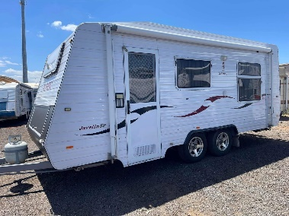

2009 Olympic Javelin dual axle caravan with bunks, queen bed, annex, heating and cooling !

FEATURES: Battery with charger . 12v stereo with speakers. 3 way fridge and freezer. 12v pump

. Stove and grill and Range hood . Microwave . Heating & cooling . Queen island bed . bunks at front (can fold up to be couch also) . Dining table also could make a bed . rollout awning . Annex . 12v lighting . Exterior light. Power lead and waste hose . Power inlet & outlet . 2x gas bottle holders . Spare tyre on rear . Exterior water tap. Front storage. Standard coupling . Electric brakes .anderson plug to fridge .portabke solar and Anderson plug available for $380 or roof mounted $780. TV on swivel bracket 18 ft Tare 1570 Atm 1970 This Olympic javelin caravan is in good condition throughout, No leaks or water damage !! This caravan will not disappoint! $28,990 neg ! Located at ECW caravan dealership Bacchus marsh vic

Can deliver, finance available !

