4944 Geelong-Bacchus Marsh Rd Maddingley, VIC, 3340

Email: [ecwcaravans@gmail.com](mailto:ecwcaravans@gmail.com)

Phone: 0424 503 022

Sunland Patriot Off Road caravan with BUNKS

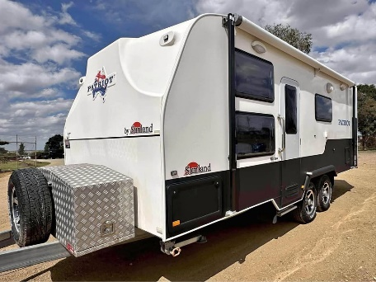

Shower/toilet, battery setup, solar and more!! This luxury family van with a awesome layout has - -Independent suspension and heavy duty 6 inch chassis - washing machine - 120 amp battery with charger - Solar with regulator - RV Wifi - Queen island bed with underneath storage - Bunk full size over 6ft - Aircon /heating -full size 3way fridge with separate freezer - 12v sockets throughout - 12v pump -12v stereo with speakers -12v Tv on swivel bracket -Toolbox mounted on front - gas/elec hot water system - Tank water and mains water setup (waste hose included) - huge water tank and mains water - Tank water gauge - Microwave - caravan cover - Stove with 4 gas burner and grilled - Wind up aerial - Ample overhead storage - Large shower/ toilet - Roll out awning - Break away brake system - electric brakes Tare 2503 kg Atm 3300 kg 20.5 ft 2016 model These are one of the best made off road caravans in Australia (made in Qld ) . If you have done your research you will know this is a great price for one of these very well built and capable caravans. In great condition and will not disappoint! Comes with Vic registration . $63,990 neg Open to reasonable offers Located at ECW caravan dealership Bacchus marsh Vic Finance and delivery available.

