4944 Geelong-Bacchus Marsh Rd Maddingley, VIC, 3340

Email: [ecwcaravans@gmail.com](mailto:ecwcaravans@gmail.com)

Phone: 0424 503 022

2006 Majestic Knight

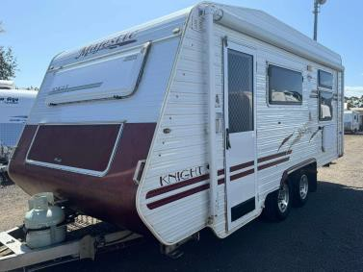$23,990

Majestic Knight caravan with annex, battery setup, aircon, diesel heater and more. This great 18.5 ft caravan has: -Island bed -Anti sway kit . -Annex -aircon only -great clearance -Battery setup with charger. -diesel heater (currently has error code and would need to be serviced ) -Anderson plug for portable solar -

portable solar available ($220) -Spare tyre -dual axle -12v TV on swivel bracket -12v water pump -12v

stereo with speakers-Tv aerial -Currently registered and ready to go . -power lead, hose and waste hose

Great kitchen with tank and mains water setup, microwave, stove with grill and range hood Double couches and table. Could be used as extra bed. This caravan has been kept in good condition !2006 model Tare

weight 1793 kg ATM 2193 kg 18f.5t $23,990 neg ! This beautiful caravan won’t last long ! Located at ECW caravan dealership Bacchus marsh Vic . Delivery and Finance available too !

