4944 Geelong-Bacchus Marsh Rd Maddingley, VIC, 3340

Email: [ecwcaravans@gmail.com](mailto:ecwcaravans@gmail.com)

Phone: 0424 503 022

2013 Coronet Prince Pop Top

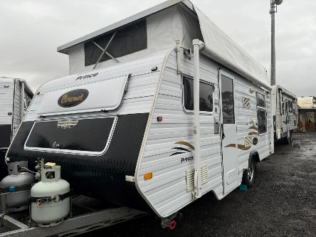

2013 Coronet Prince with island bed, roll out awning, battery, hot water system and outdoor shower This beautiful condition pop top has:-Club lounge -Outdoor shower with hot and cold water. -battery with charger-Aircon and heating -Queen Island bed at rear with underneath storage -2x wardrobes -12v pump -12v Stereo with speakers -Reverse camera -awning (does have small repair patch ) -Bedside reading lights -Shower tent -Front club seating -Tv aerial (portable -TV-Australian made -Fully insulated!-Great kitchen with tank and mains water setup, microwave, stove 4 burners, grill, range hood, microwave and 3 way fridge with freezer . - Water tank gauge -Gas hot water system -Anderson plug to battery New Portable solar available for $220 Very well looked after 1440 kg tare only. 1785 kg ATM 2013 model. 17 ft This caravan is currently registered and ready to go! $23,990 neg . Located at ECW Caravan dealership. Bacchus marsh VIC Finance available too! Delivery aus wide

