4944 Geelong-Bacchus Marsh Rd Maddingley, VIC, 3340

Email: [ecwcaravans@gmail.com](mailto:ecwcaravans@gmail.com)

Phone: 0424 503 022

2018 Jayco Journey Poptop $39,990

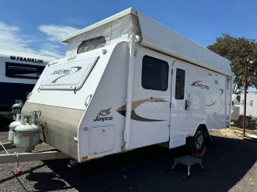

2018 Jayco Journey pop top caravan with separate shower and toilet, roll out awning, battery setup and island bed. Sleeps 2-3 people These great layouts have everything you need at only 16.8ft! Included -\*Battery setup with charger\*12v lighting\*12v pump \*usb sockets \*gas/elec hot water system\*dual Tank water and mains water setup. \*hose and power lead \*Awning with LED strip lighting and flooring \*spare tyre Bathroom with shower, toilet and basin. Large kitchen with 4 burner stove (3 gas & 1 elec), grill and range hood, 3 way fridge, microwave, lots of storage and more. Great caravan, tows well & lots of extras !\*Electric brakes to all wheels. \*front boot \*2 x gas bottle holders and bottles\*break away system \*Aluminium frame and fully insulated !!! Beautiful condition Comes registered and ready to go. Tare weight 1523 kg ATM 2897 kg 16.8 ft. 2018 model $39,990 neg !!!! Located at ECW caravan dealership in Bacchus Marsh Vic. Finance and delivery aus wide available. Trade ins accepted (caravans only) This caravan won’t disappoint !

