4944 Geelong-Bacchus Marsh Rd Maddingley, VIC, 3340

Email: [ecwcaravans@gmail.com](mailto:ecwcaravans@gmail.com)

Phone: 0424 503 022

2011 Safari X-Trak Off Road

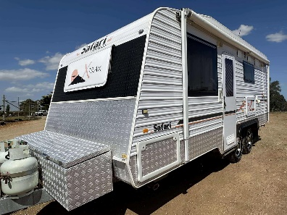

Safari X-Trak Off road caravan with shower, toilet, 3x solar, 2 x batteries , free camp setup and LOTS of great extra features in stunning condition ! Desirable features including: \*independent suspension \*6 inch heavy duty chassis \*queen bed 3 x Solar panels with reg \*2 x batteries with charger \*stove (3 gas + 1 electric) and grill \*12v TV and swivel TV bracket \*Reverse Cycle A/C and heating. \*12v bluetooth/Radio/CD player with speakers inside and waterproof outside speakers. \*12v pump \*12v lighting \*gas/elec hot water system \*eco therm water heater \*Large rear ensuite featuring spacious shower \*washing machine \*Roll out awning with privacey screen \*Reversing camera \*toolbox on rear for generator \*toolbox on front \*Anti sway kit

\*Microwave \*large 3 way Fridge/ seperate freezer. \*Cafe dinette seating with tri-fold table

\*water level indicator \*dual water tanks \*Exterior fold down picnic table \*Wind up aerial

\*Electric brakes and safety break away system. WAY to many features to list ! A caravan like this at this price will not last long in the yard !! 19.8 ft 2011 model ! Tare 2150kg ATM 2550kg

$38990 !!! Located at ECW caravan dealership Bacchus marsh vic ! Finance and delivery available Trade ins accepted (caravans only).

